Disease model explanation

Model:

In this project, we use the SIR model as nominal dynamic process.

S: susceptible, people can be infected

I: infectives, people who get infected

R: recovery, people who recover from disease and become immune to disease

A: average contact rate, A=0.2

b: the amount of time that a person is infections, b=10

N = S+ I + R (total population)

$$\frac{dS}{dt}=\frac{-ASI}{N}$$

$$\frac{dI}{dt}=\frac{ASI}{N}-\frac{I}{b}$$

$$\frac{dR}{dt}=\frac{I}{b}$$

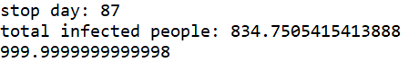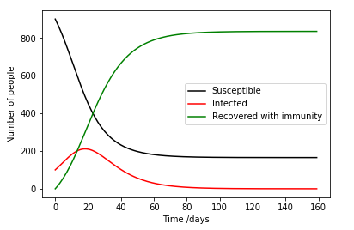

Figure.1 Result of the nominal situation

In this case, we can see that this epidemic process stops at 87 day, and there will be 874 people will get infected.

To prevent more people get infected, Government can have 2 intervention policies in this model.

a: contact rate after policy 1

n: increasing number of medical staff per step

V: people get vaccine per step after policy

m: default number of medical staff

alpha: threshold value to trigger policy 1

IR: threshold value to trigger policy 2

Policy 1: if infected people portion bigger than alpha, then contact rate will drop to a, 5 susceptible people will get vaccine per step.

$$\frac{dS}{dt}=\frac{-aSI}{N}-V$$

$$\frac{dI}{dt}=\frac{aSI}{N}-\frac{I}{b}$$

$$\frac{dR}{dt}=\frac{I}{b}+V$$

Policy 2: if infect rate bigger than IR, add n medical staff per step, recover rate will increase according to medical staff number, c = (m + n) / m

$$\frac{dS}{dt}=\frac{-ASI}{N}$$

$$\frac{dI}{dt}=\frac{ASI}{N}-\frac{cI}{b}$$

$$\frac{dR}{dt}=\frac{cI}{b}$$

When Policy 1 and Policy 2 both trigered.

$$\frac{dS}{dt}=\frac{-aSI}{N}-V$$

$$\frac{dI}{dt}=\frac{aSI}{N}-\frac{cI}{b}$$

$$\frac{dR}{dt}=\frac{cI}{b}+V$$

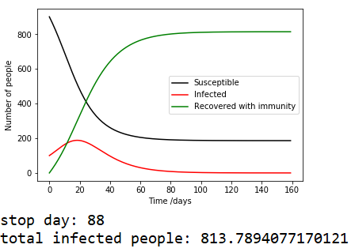

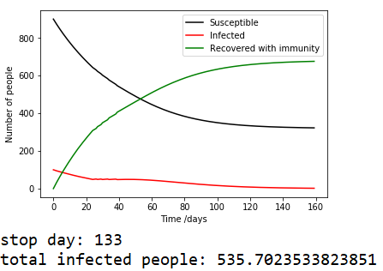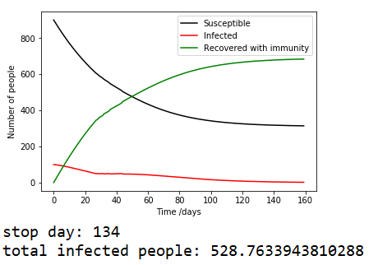Figure.2 Result under Policy 1 Figure.3 Result under Policy 2

Figure.4 Result under Policy 1&2

As you can see from Figure.2, Policy 1 can make the total infected people number drop from 834 to 528. However, Policy 2 is not that effective because it cannot make the total number of infected people drop largely or end this epidemic process earlier.

After creating the model, we need to construct our objective function.

Since we want to minimize the cost in the whole process:

Cost = healing people expense + economy damage + medical staff salary

Cost = Imax\* H + (A-a) \* N \* E \* T + Em\* Tm

Independent variables are (a , n , V , m , alpha, IR)

Imax: total number of the infected people by this disease

H: healing fee for this disease

N: total population

E: expense per people per day

T: intervention lasting time,

Nm: total number of medical people

Em: medical staff income per hour,

Tm: extra medical staff total working hours

We use scipy.optimize library to optimize. Considering the Policy 1 and Policy 2 will make the function to be non-continuous, we use to differential evolution method to optimize.

We set a bound and we will get a result.

 Figure.5 setting bound and use differential evolution method

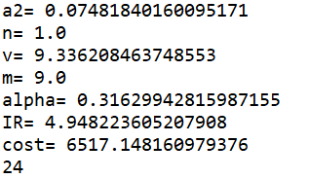

Figure.6 Result from the optimizer

Reference:

Kermack, W. O., and A. G. McKendrick. “A Contribution to the Mathematical Theory of Epidemics.” Proceedings of the Royal Society of London. Series A, Containing Papers of a Mathematical and Physical Character (1905-1934), vol. 115, no. 772, 1927, pp. 700–721.